MS Lobe

## Image Recognition on Web Browser

1. Visit <https://lobe.ai/> Website
2. Click on **Download**

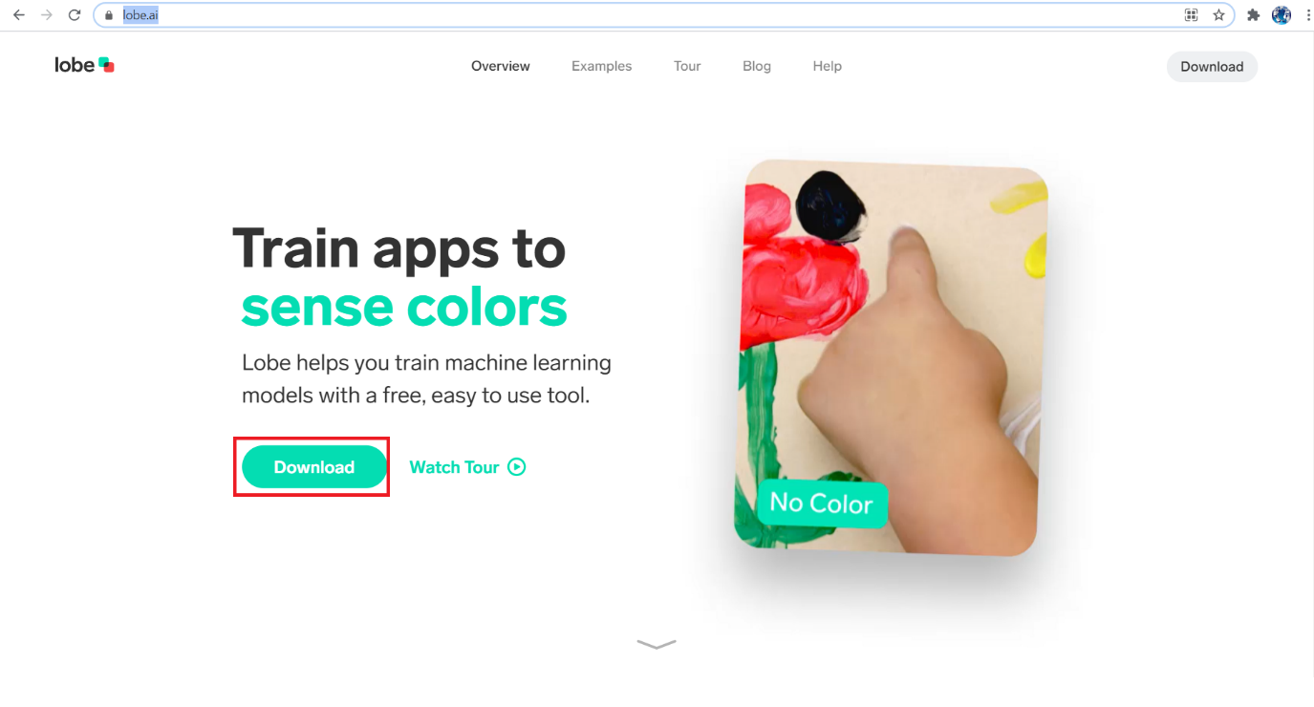

1. Enter **Name, Email ID, Purpose.** Select the Country and Click **Download.**

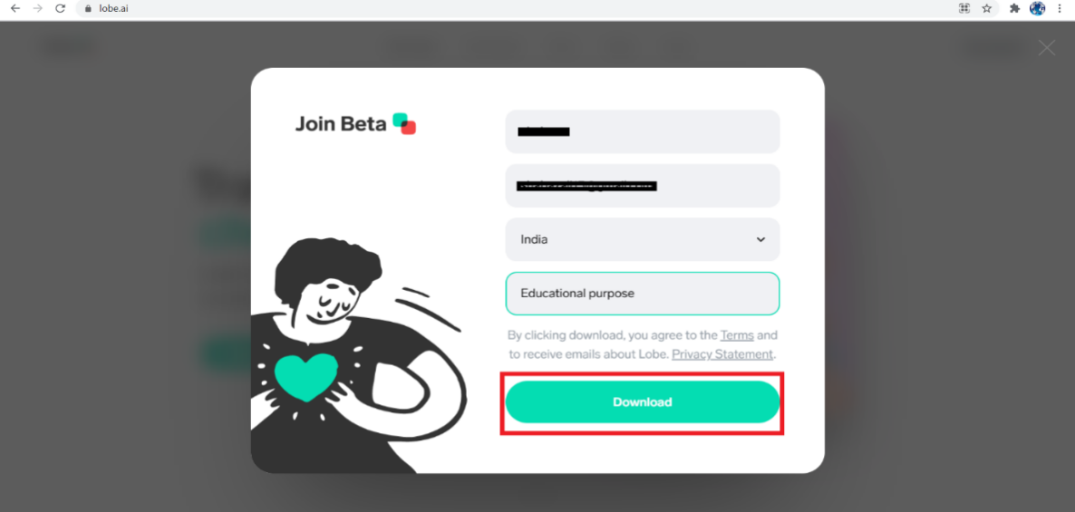

1. File is being **Downloaded**

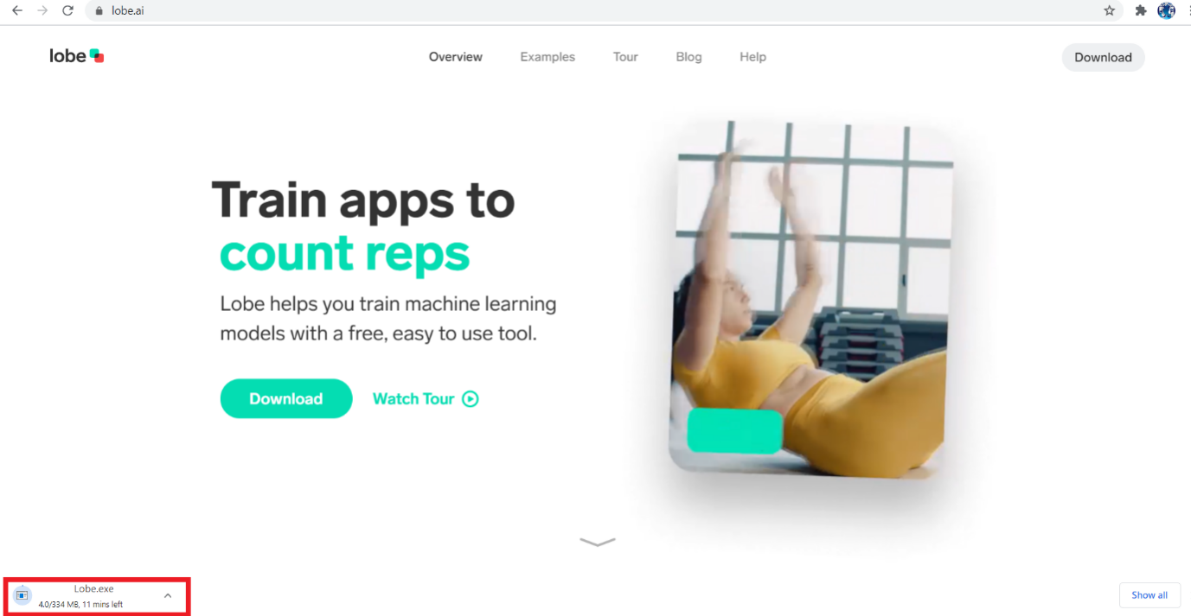

1. Start Installing the Downloaded file. And Click **NEXT**

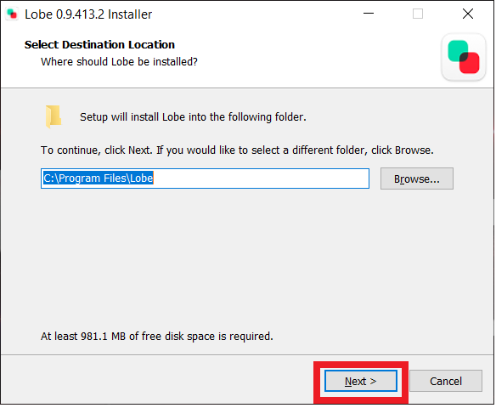

1. Installation will take place. After that Click on **Finish**

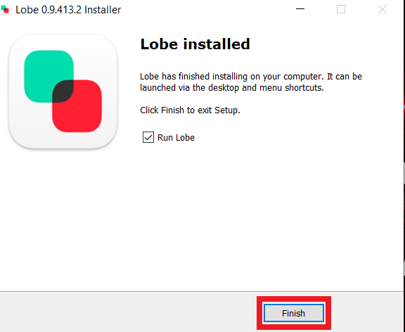

1. Click on **Agreed**

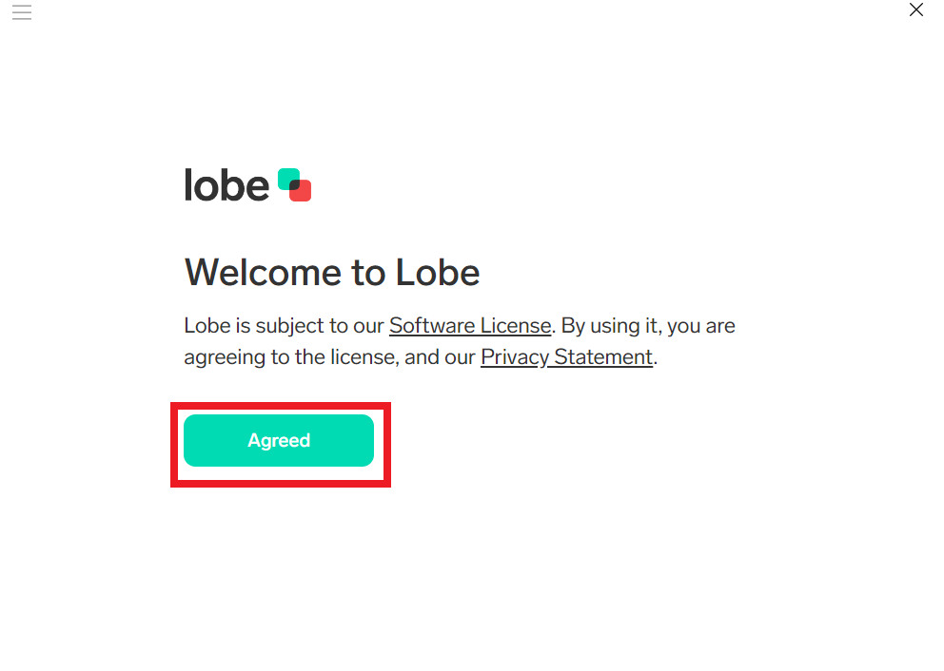

1. Click on **Okay**

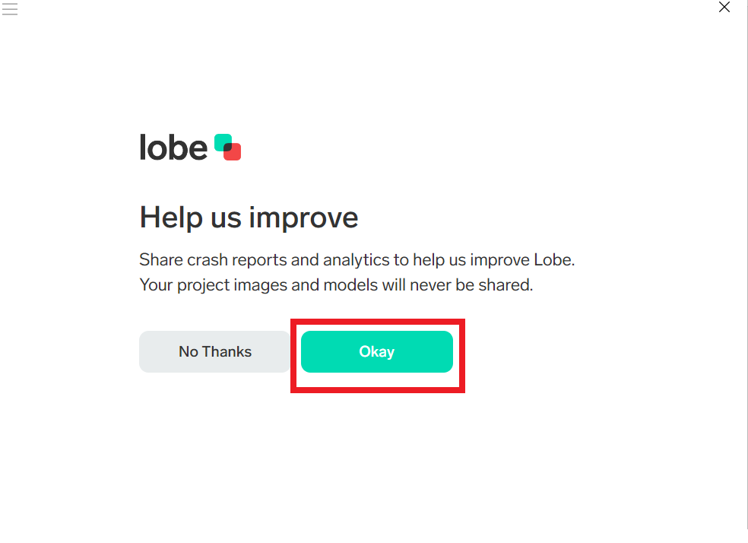

1. Click on **Get Started**

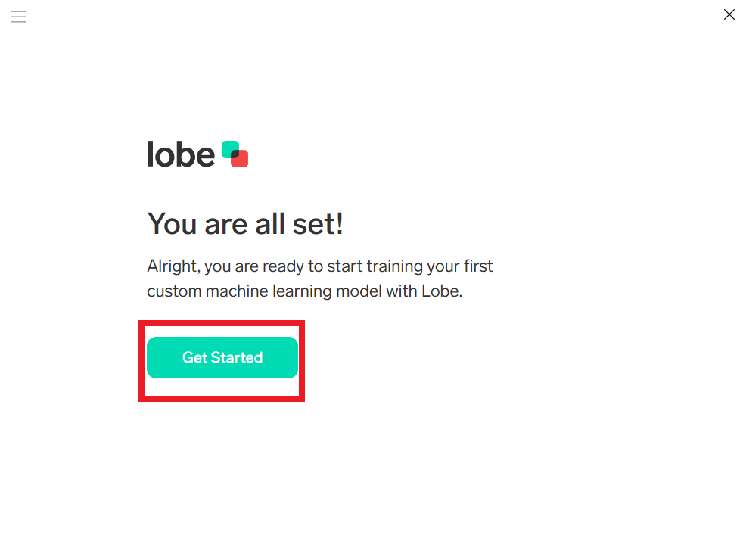

1. Name the Project. And Click on **Import.** To Upload Images from the System.

(NOTE: My project is to train my system Difference between Fruits and Vegetables)

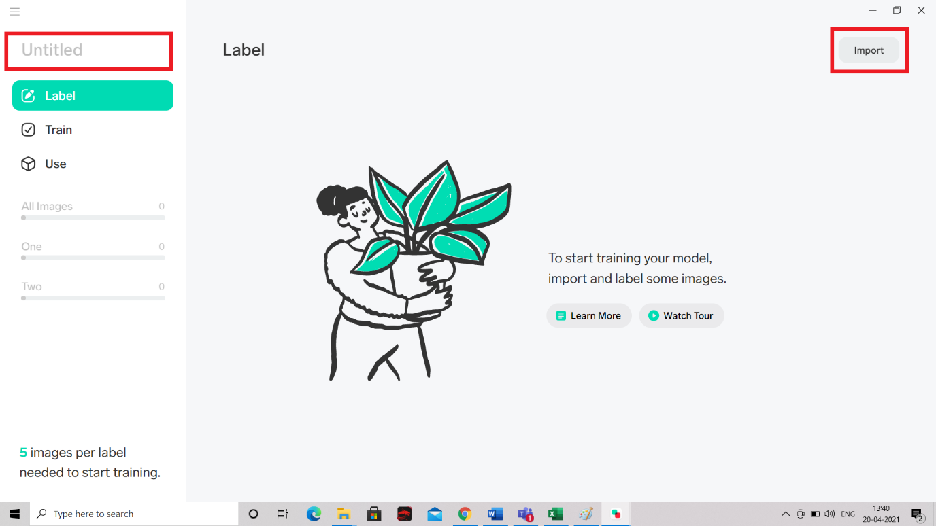

1. Click on **Images**

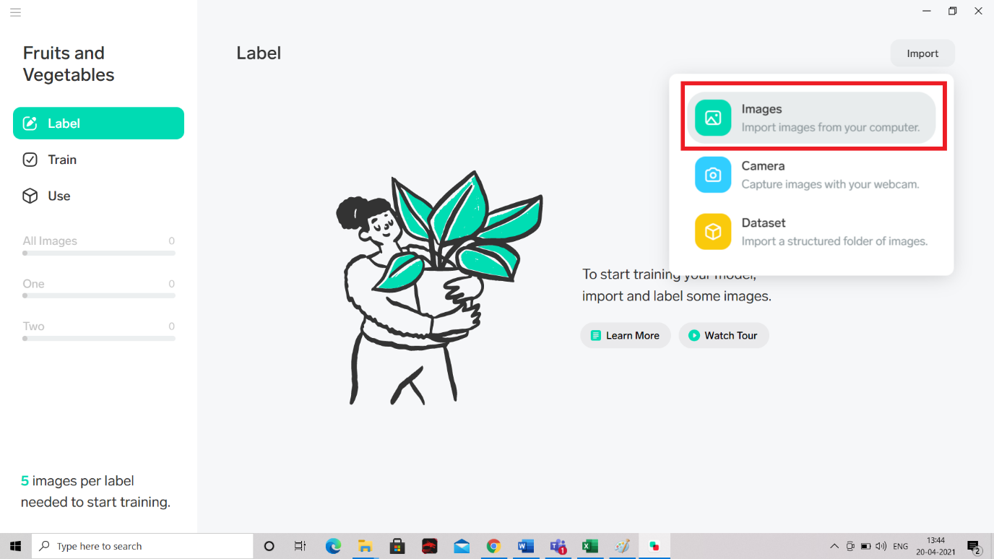

1. Select all you Project Images

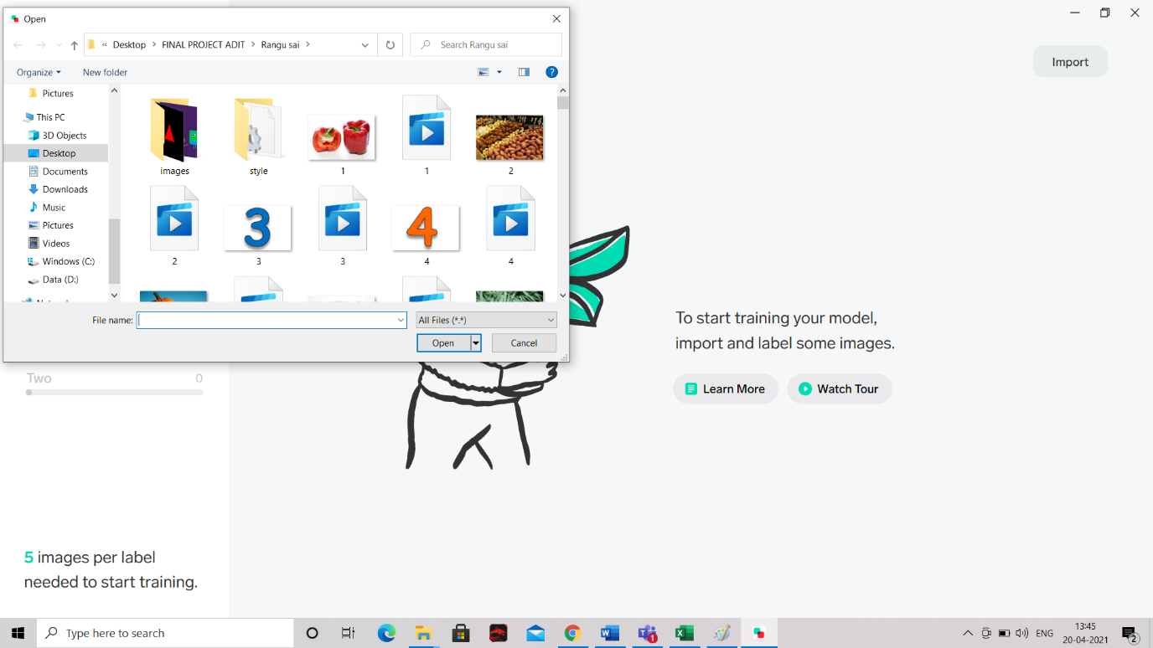

1. Label them Accordingly e.g., - Vegetables and Fruits

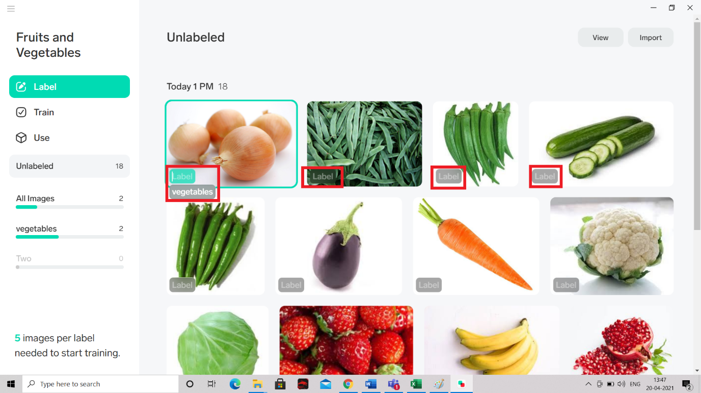

1. Training Will be done Automatically and Click on **USE**

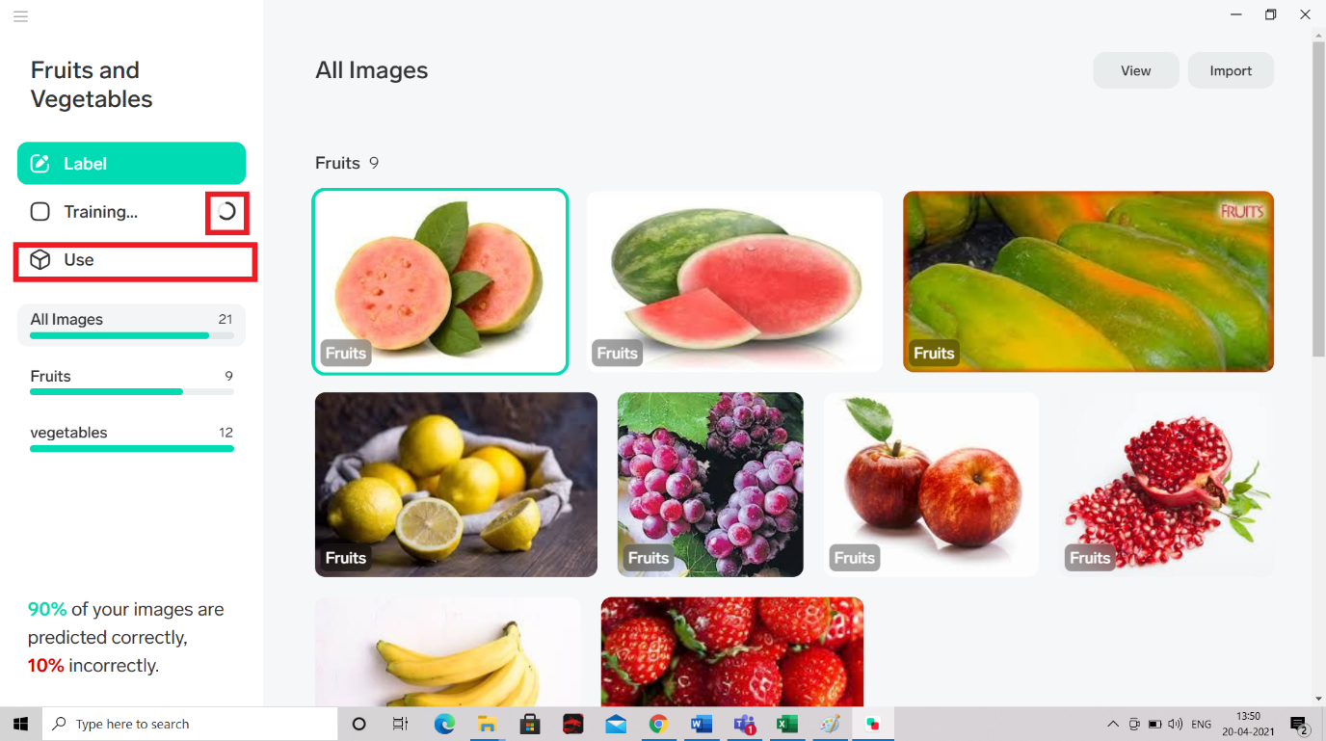

1. Click on **Import** images for Testing (Select an image for testing)

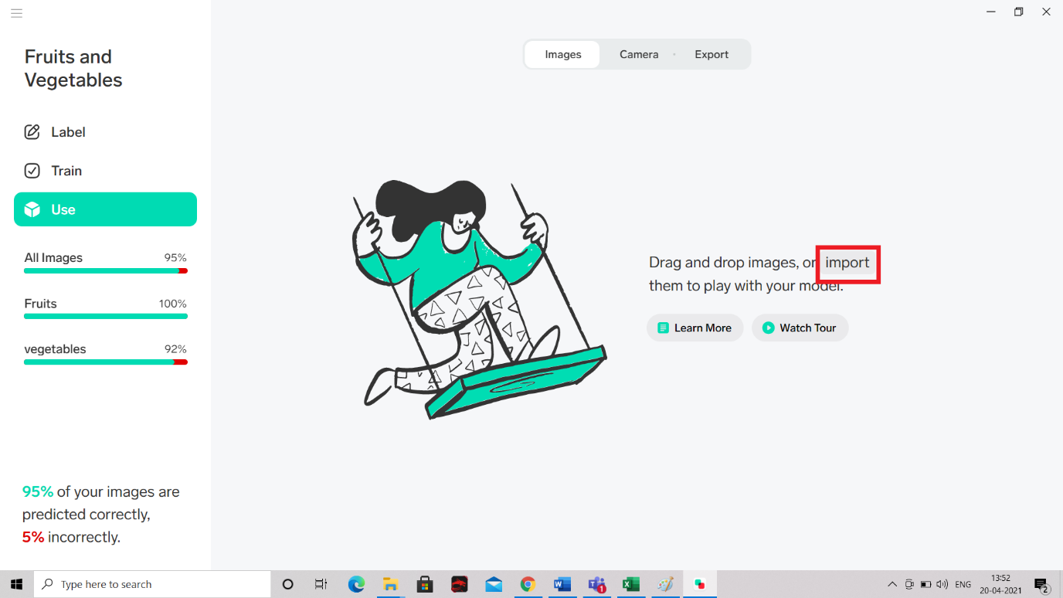

16.The Result will be Shown Down. If it is Correct Click on Right. If it is wrong Click on Wrong Which will help to learn more to the system

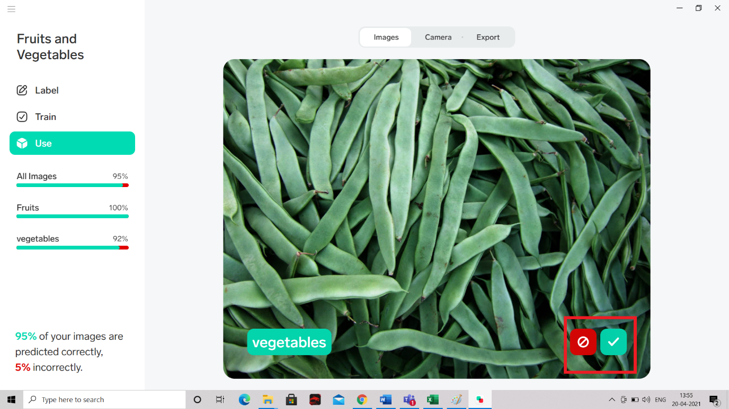

So, in this chapter we have seen the history, market trends and opportunities in the very exciting field of Artificial Intelligence and also discussed about the fundamental concepts in AI and machine learning. We also explored practically some of the applications of AI and Machine Learning like sentiment analysis, Natural Language Processing and Image classification. We explored an overall understanding of what is AI, ML and its real-life applications.

In the next chapter we will be discussing about Data Analysis, Anaconda Software and key concepts in Python Programming language.